LAB REPORT - 04
Problem Statement: Implementation of Breadth-First Search (BFS).
Objectives:
- To implement the Breadth-First Search (BFS) algorithm using an adjacency matrix in C++.
- To traverse all reachable vertices of a graph starting from a given source vertex.
- To determine whether all vertices in the graph are reachable from the starting vertex.
Source Code: Input & Output:
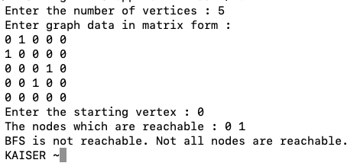
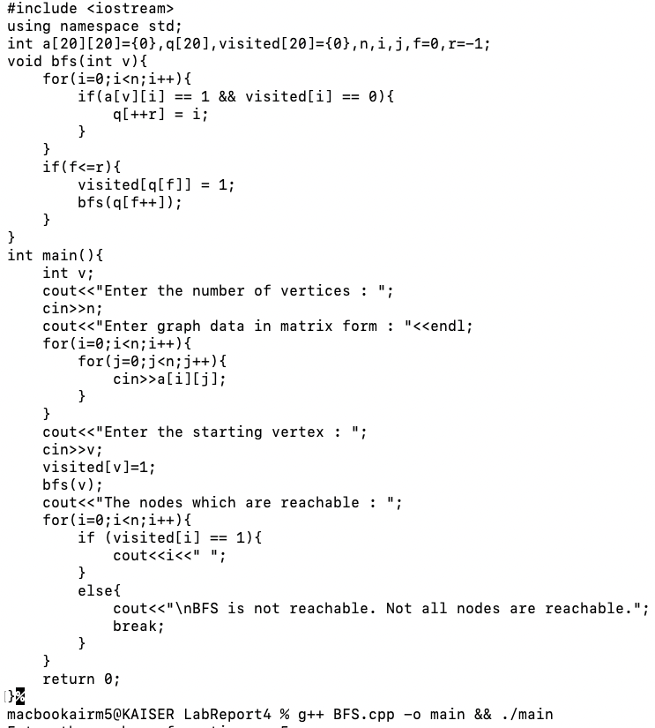

Problem Statement: Implementation of Depth-First Search (DFS).
Objectives:
- To implement the Depth First Search (DFS) algorithm using recursion in C++.
- To traverse all vertices of a graph starting from a given source vertex.
- To identify and display the order in which the vertices are visited during DFS traversal.
Source Code: Input & Output:
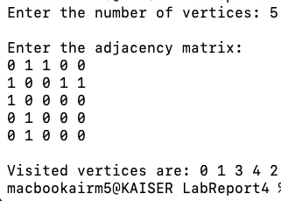
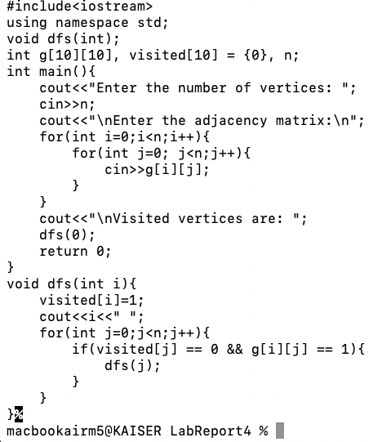

Conclusion:
The Breadth-First Search (BFS) and Depth-First Search (DFS) algorithms were successfully implemented using an adjacency matrix to represent the graph. The BFS algorithm traversed the graph level by level from the given starting vertex and verified whether all vertices were reachable from the source. In contrast, the DFS algorithm explored each reachable vertex by moving as deep as possible before backtracking, using recursion. The traversal order of both algorithms was displayed successfully, demonstrating their different approaches to graph traversal. Overall, the implementation helped in understanding the working principles, traversal patterns, and practical applications of both BFS and DFS algorithms.

